* **The Names of the 20 animators and five coordinators and One Cluster Level Coordinator:**

|  |  |  |  |  |
| --- | --- | --- | --- | --- |
| **SL.NO** | **MANDAL** | **VILLAGE** | **ANIMATOR** | **MOBILE** |
| 1 | Thaticherla Motu | THATICHERLA MOTU  Motu Colony | T. SUJATHA | 7659902419 |
| 2 | BESTHAVARIPETA | CHRISTIAN PALEM KAZIPURAM | VIJAYAKUMARI , E. SATYA SUDHA | 9000894587  9100541652 |
| 3 | KANIGIRI | KUCHIPUDI COLONY GANUGAPENTA | K. SARALA ,  A. NIRMALA | 8096753881  8374834586 |
| 4 | GIDDALORE | JAYARAM PURAM , SATYAVOLU | G. JYOTHI ,  C. SWARNA | 8096668373 |
| 5 | KOMOROLE | BAPANENI PALLI,  GOPANNA PALLI | ROSE MARY | 7032698668 |
| 6 | DARSI | VULLAGALLU, VENKATAPURAM | GADDI GRESAMMA, KONDA NAGENDRAMMA | 9553518438  9848646839 |
| 7 | PODILI | NANDIPALEM, MANGAPURAM | R. LUDIYA, MARY SUBAMMA | 9704038284  9000454130 |
| 8 | SIDDAVARAM | CHINTHALAKUNTA, SIDDAVARAM | D. NIRMALA ,  CHINAMMA | 9866616188  7660060685 |
| 9 | RACHERLA | CINAGANIPALLE, J.PULLALA CHRUVU | E. NIRMALA ,  P. GRESAMMMA | 9866983988 |
| 10 | H.M PADU | DASARIPALLI ,  HAZIPURAM | U. LAKSHAMMA,  J. LAKSHMIDEVI | 9652338963  8106263929 |

**The Five Coordinators Are**

|  |  |  |
| --- | --- | --- |
| Sl. No | Name | Villages Covered |
| 1 | VIJAYAKUMARI , E. | CHRISTIAN PALEM  KAZIPURAM  BAPANENI PALLI  THATICHERLA MOTU |
| 2 | T. SUJATHA | JAYARAM PURAM ,  SATYAVOLU  CINAGANIPALLE, J.PULLALA CHRUVU |
| 3 | D. NIRMALA | CHINTHAKUNTA,  SIDDAVARAM  DASARIPALLI ,  HAZIPURAM |
| 4. | A. Sunitha | NANDIPALEM,  MANGAPURAM  VULLAGALLU,  VENKATAPURAM |
| 5. | P. Kiran | KUCHIPUDI COLONY GANUGAPENTA |

* **The Cluster Coordinator: P. Kiran Kumar**
* On May 8, 2015 Mrs. Sireesha from Podili has given animation on Four Issues: 1. **CHILD LABOUR 2. HEALTH AND HYGENIC 3. GOVERNMENT SCHEMES AND 4. WOEMN RIGHTS**, and went to the Diocese Nellore to visit our Bishop and attended CRS Review meeting at Nellore.

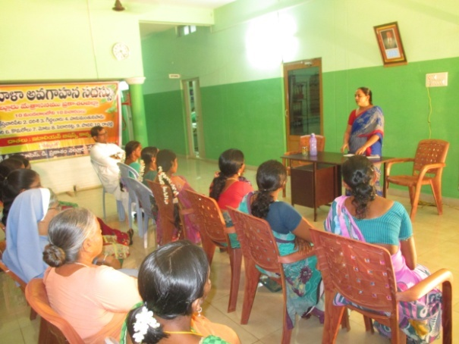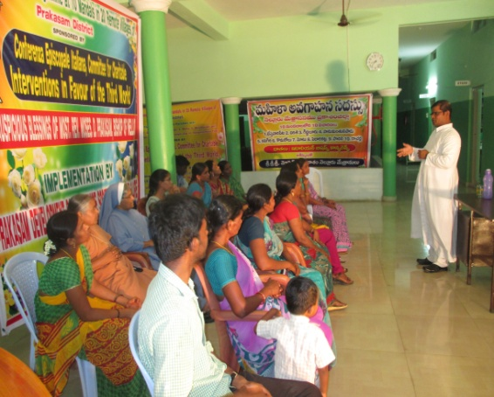 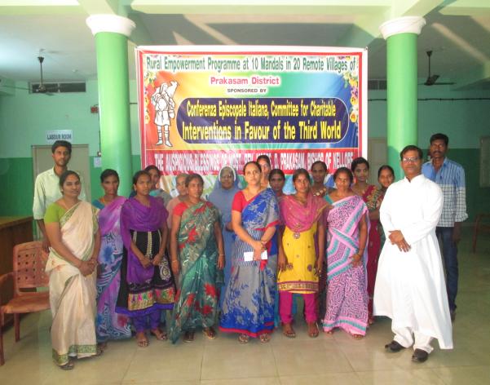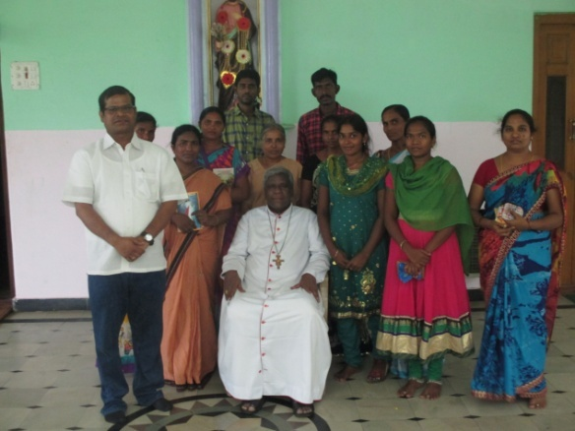

**CRS Meeting at Nellore**

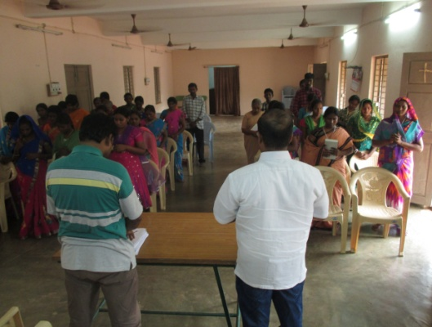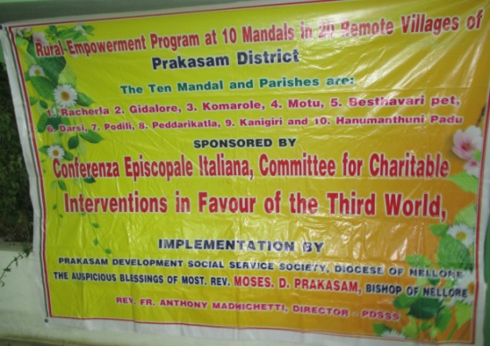

* Women empowerment programme **in J. Pullacheruvu Parish in Rachera Mandal**. Re. Fr. Hrudaya Raj was the resource person and S. Jaya Raj, the Parish Priest of J. Pullachruvu also was present and enlightened the women and requested them to form the groups. There were 50 women 40 men attended this programme

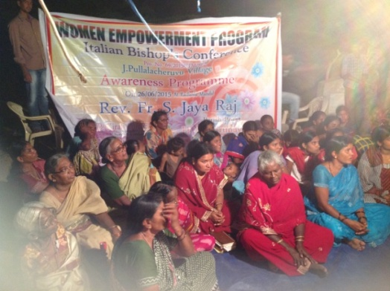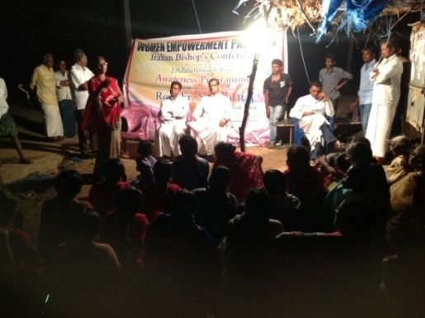

* Animation programme with one Self Help Group at Kanigiri Parish. Fr. Anthaiah the Parish priest giving instrction for the grop to animate and to cooperate

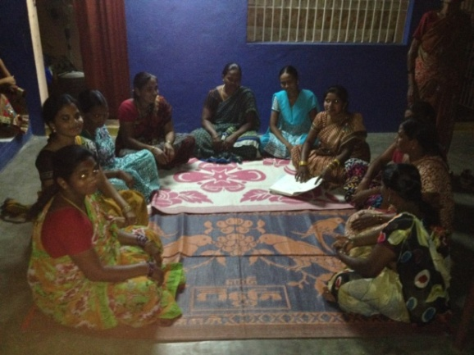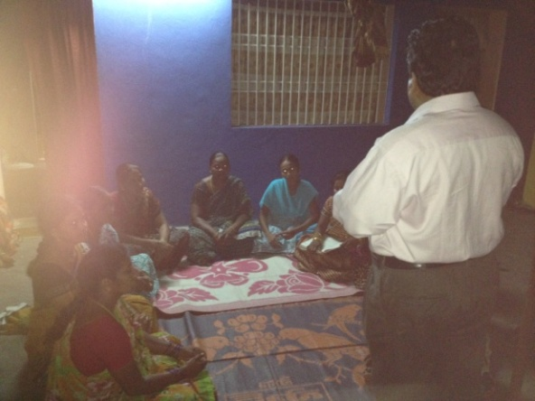

* June 8- 10, 2015 three day Workshop was arranged for the twenty animators at Podili and Mrs. Madhavi Latha from Secunderabad, Telangana State was the Resource Person for this workshop. The programme was very success; all the animators and Coordinators participated. Our Bishop Moses D. Prakasam was also present and gave the instructions to do well and bring awareness in the villages.

**Bishop with Animators**

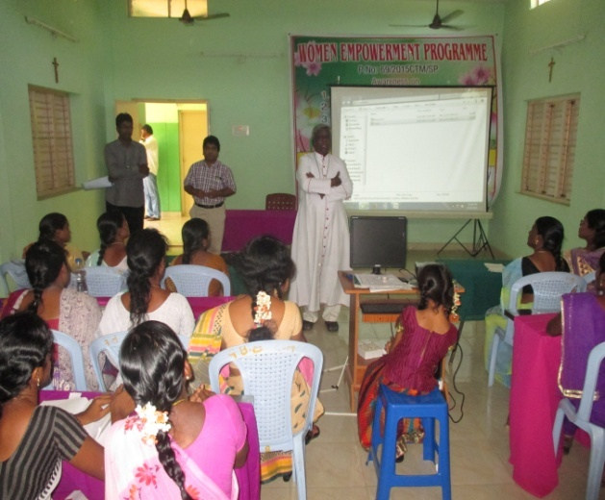 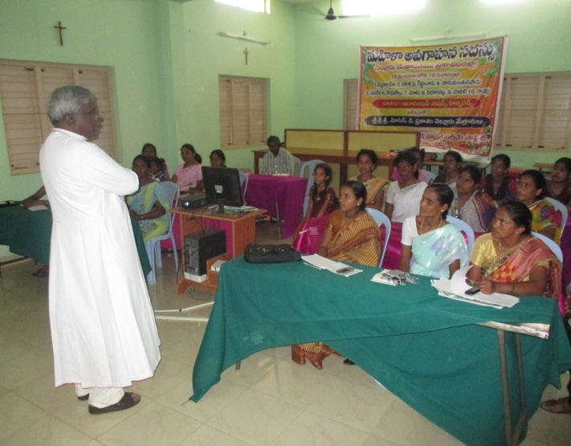

**Mrs. Madhavi Latha** from Secunderabad, the resource person for the three day Training Programme for twenty Animators, coordinators and Cluster Level Coordinator at PDSSS, Podili

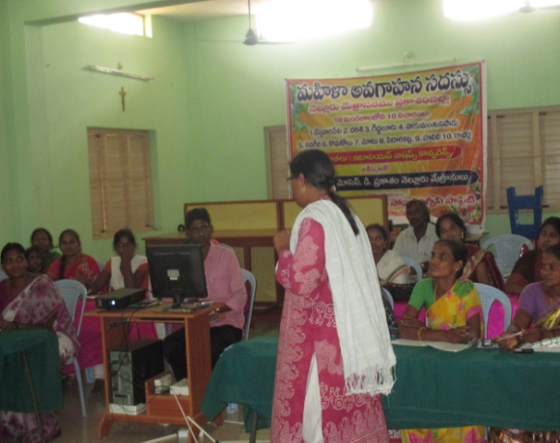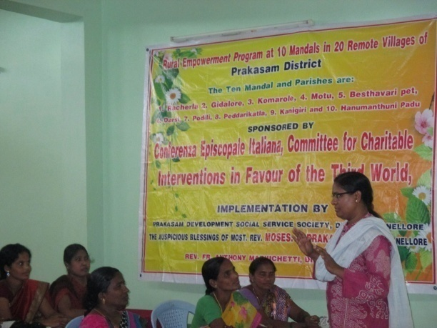

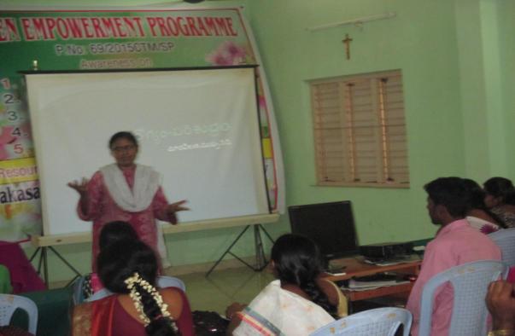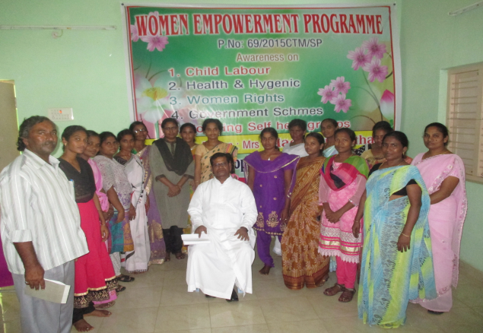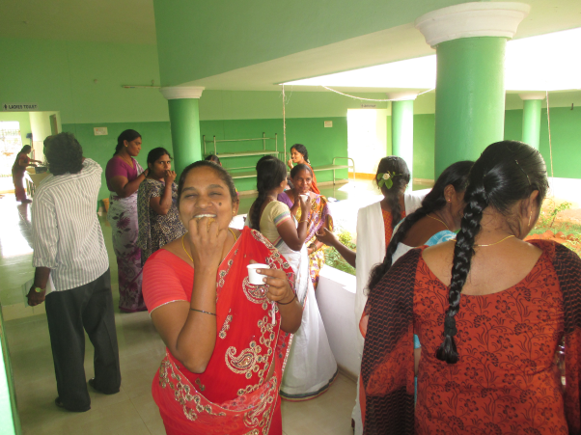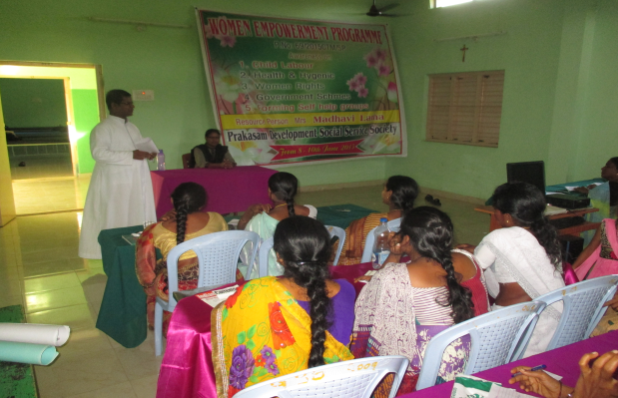

1. Food Security Programme was excellently organized by Fr. M. Hrudaya Raj at Khazipuram. There are thirty eight families in the village. The work started at 7.00 A.M on 27th June, 2017 and all the families participated whole day in the food security programme and at the end of the Thirty eight families received Rice, Doll(Lintels) and Oil for cooking.

**Cleaning the Roads: Director and the Parish Priest also participated**

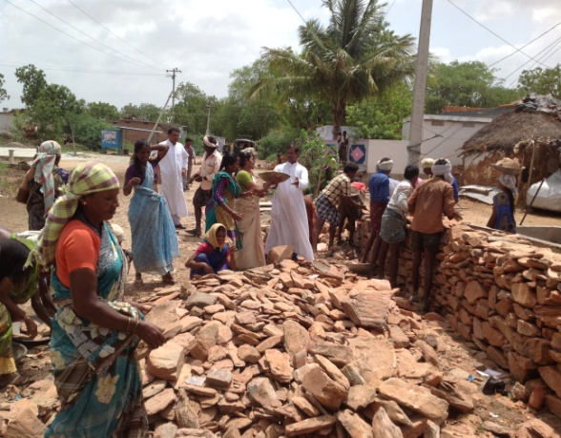 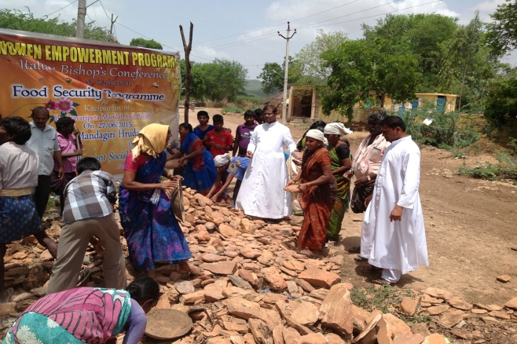

**Food Grains Distribution**

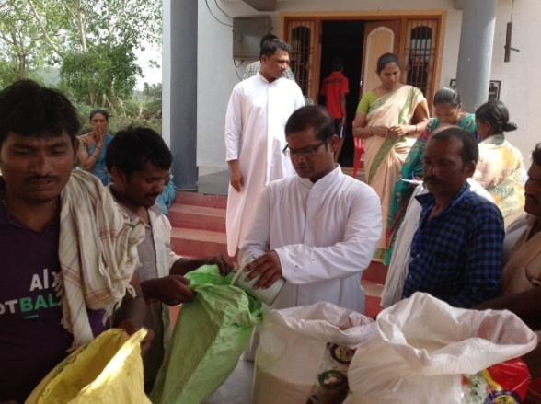 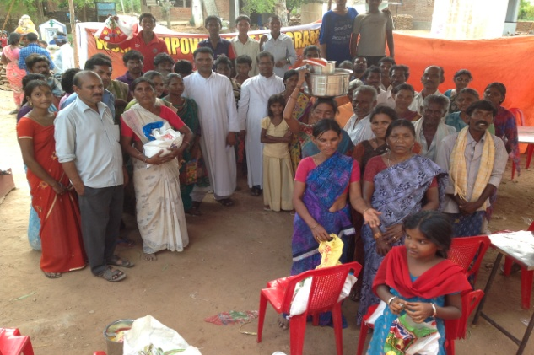

**Animation and Foming the groups Director cutting the thorn bushes**

